

**Big Data Architecture and Governance Project Report**

**-Pujitha Sriramaneni**

## **About:**

Herc Rentals Inc. is a full-service equipment rental firm providing customers the equipment, services and solutions they need to achieve optimal performance safely, efficiently and effectively.

With more than 50 years of equipment rental expertise, approximately 4,800 employees and approximately 275 company-operated locations primarily in the United States and Canada. Herc Rentals serves a broad range of customer markets, including large and small companies in construction, industrial customers such as large industrial manufacturing plants, refineries and petrochemical operations and other customers such as governmental entities and government contractors, disaster recovery and remediation firms, infrastructure,  railroads , utility operators, individual homeowners, entertainment production companies, agricultural producers, special event management and facility management firms.

## **Challenge:**

For an equipment rental company like Herc, missing a quarter tank of gas or missing negligible number of equipment may not seem like a big deal. Spread that over 100,000 pieces of equipment in the field across a year and it equates to millions of dollars. Although the company had been using sensors for various purposes over the years this huge loss wasn’t been handled in an effective manner.

## **Solution and Project Objective:**

combining the sensor equipment with a robust telematics platform to address the issues by tracking equipment and optimizing operations. Re-architecting the company's ProControl online application with an intuitive user interface and to create a unified view of telematics data to help employees utilize new capabilities to remotely manage the location, availability and condition of equipment. In part, the solution provides real-time monitoring of equipment asset status, indicating inefficiencies like under-utilization and misuse. With an effective and accurate means of tracking how and where rental equipment is being used, Herc can offer flexible subscription/chargeback models to its customers.

## **Functional Requirements:**

* Real-Time monitoring and data streaming from all rented equipment.
* User Roles: Customers

Herc employees(Customer service, Data Analyst, Admin)

* Authentication layer and specific privileges for each role.
* Alerts on equipment condition and supplies to herc employees prior to breakdown.
* intuitive user interface.
* Data storage in Cassandra.
* Auto Data Analysis options according to user role.

## **Non-Functional Requirements:**

* Performance – Data usage, Response time, Processing time.
* Recovery – Backup time.
* Scalability – Risk Tolerance, Storage, Future Scope, Code Reusability, Growth Requirements.
* Maintainability – Security, Architectural standards, Coding standards
* Store reviews – Branch wise, usage of each device and able to give graphs to help in analysis which equipment is highly rented, which equipment is highly trustworthy. which equipment is maximum rented per each branch.

## **Project Flow**

Step 1: The data from sensors is captured using OracleIoT and streamed in to streaming analytics.

Step 2: The data is analyzed and tested for any faulty patterns of equipment and stored in Hadoop.

Step 3: Any threatful patterns are identified and alerts will be sent to the Appropriate roles of users.

Step 4: The Data stored will be retrieved when asked by the customer or herc employee

Step 5: Hadoop allows to recover deleted and erroneously input data. Rebuilds the environment and data from last saved backup

## **Technical Requirements:**

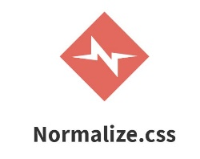 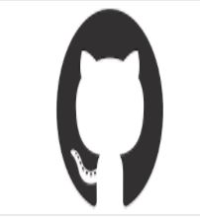 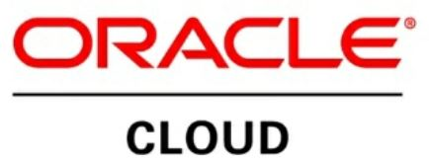 

## **Functional Architecture:**

Raw data from sensors Processed Data Stored in Hadoop

Raw Data 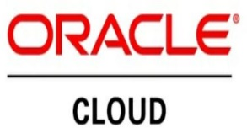 

Information

Transmitting

OracleIoT

Streaming Analytics Alerts and Info Alerts and Info

Data Analysis Employee Portal Customer Portal

 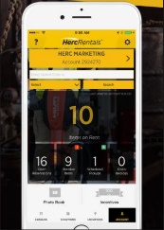 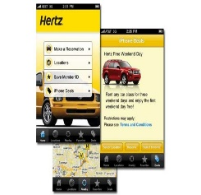

## **Technical Architecture:**

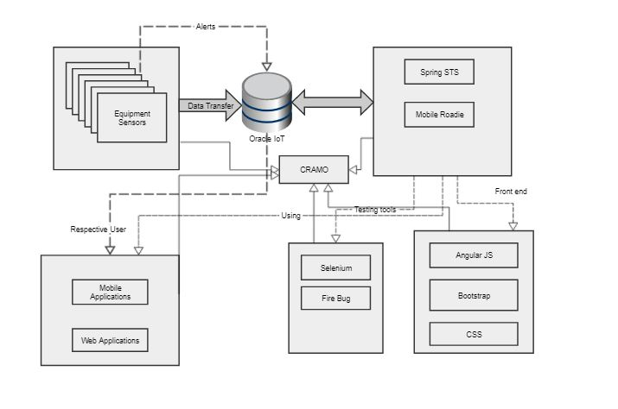

## **Issues:**

## **Integration Issue:**

Since we are using several tools in the development process, Integration of the code would face severe issues like incompatible version or some part of the code might not work to the expectations which will rise quality issues.

## **Deployment Issue:**

While Deploying the project on the client server. Since halting the rental process might cause huge loss it Is recommended to deploy the application during non-Peek hours. There might be a clash between already existing versions of software and Transferring the old data in to new server might not be tough.

## **Risks:**

## **Data Retrieving:**

After saving the old data in to the server, if there are any changes made to the data hierarchy data retrieval will not be possible. It is necessary to have a look at existing data and decide on the architecture to avoid this risk.

## **IOT EXISTENCE:**

Since IoT is an emerging technology and there are possibilities for both positive and negative fall. Among the people security and privacy of the user data are the major concerns in adoption of Internet of Things. Technology as said in the Intelligence Survey conducted by Business Insider. In new technology, a lot of machines or devices would communicate with each other, so there will be some radiations emitting out of it, which we will be exposed to. Technology helps humans to solve their problems but excess of it will make humans lazy and reduce their efficiency in thinking as we can see our older generation can remember things better than us. More exposure to radiation means more health problems.

**Expected growth in revenue:**

Intuitive user experience is expected to give high growth in revenue. Key factor for this change is allowing the customer to extend the rented equipment return date from the mobile application and web application. Customers are also allowed to return the equipment in any of the branches in the same city or a different one.

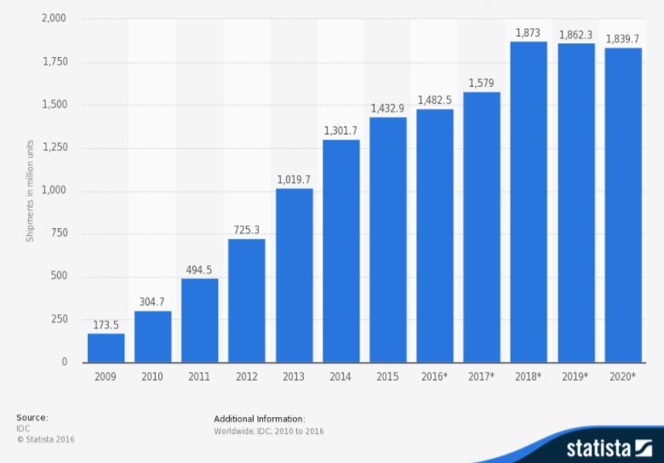

## **Resource Allocation:**

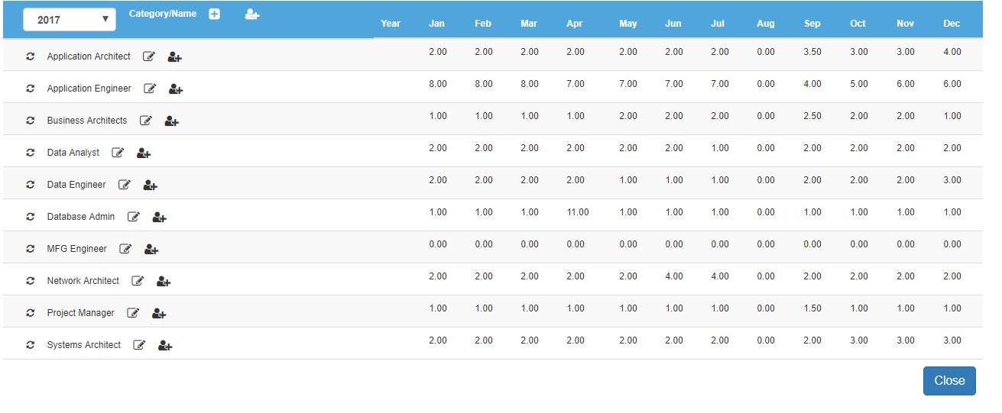

## **Budget Allocation:**

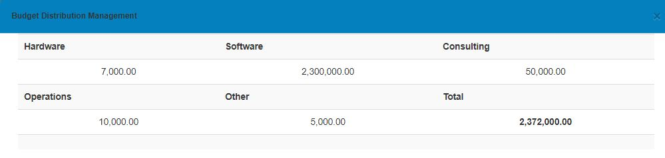

**Backup & Recover:**

Oracle IoT Provides all the features it provides for OracleDB. control file is to reconstruct and make it available to the Oracle database server to restore a physical backup of a datafile . To recover a restored datafile is to update it by applying archived redo logs and online redo logs, that is, records of changes made to the database after the backup was taken.

**Future Scope:**

IoT is an emerging technology. There can be many upgrades available for the same application and since we are following all the coding standards the future applications could be built up on the same project. There might be a system where the equipment can be directly rented to another customer from existing customer if their locations are same. Just like Uber Pool and Uber Eats.